Multilevel Truncated Negative Binomial Regression for Length of Stay Analysis

Data Preparation and Cleaning

Length of Stay Distribution
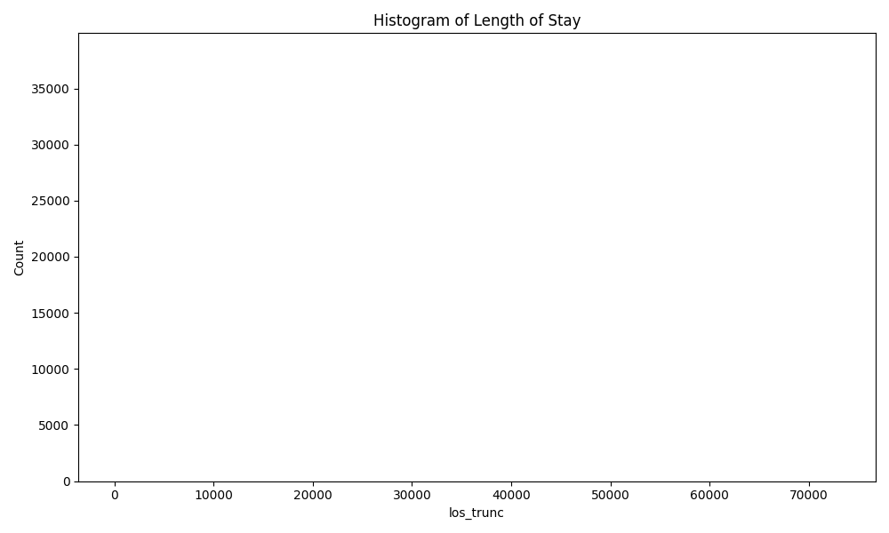
Figure 1: Histogram of Length of Stay (Before Capping)

Capped Length of Stay Distribution
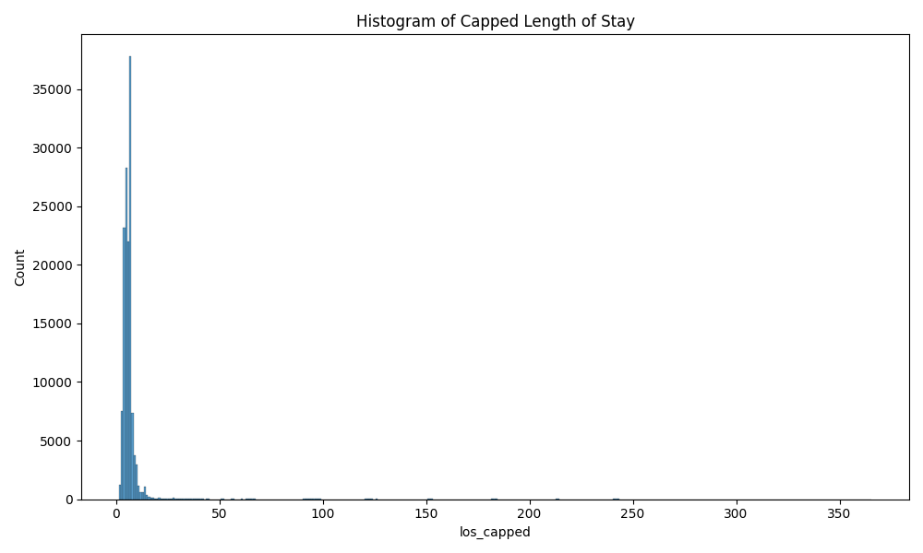
Figure 2: Histogram of Length of Stay (After Capping at 95th Percentile)

Length of Stay Summary Statistics
Statistic | Value
count | 141862.0000
mean | 10.0063
std | 404.4582
min | 1.0000
25% | 5.0000
50% | 6.0000
75% | 7.0000
90% | 8.0000
95% | 10.0000
99% | 28.0000
max | 73109.0000

Purpose of Visit Distribution
Purpose Category
1.0 (Business): 2502
2.0 (Events): 2050
3.0 (Wedding): 6566
4.0 (Pleasure): 122852
5.0 (Other): 6084

Negative Binomial Regression Model
Model formula: los_capped ~ immigrant_population_log + import_from_slu_log + age + state_percapita_income_log + state_unemployment + immigrant_density + climate_distance + economic_distance + C(sex_enc) + C(marital_status_enc) + C(employment_status_enc) + C(purpose_simple) + C(accomd_type_enc) + C(season_enc) + C(us_state_enc) + C(region_census_enc)
Model formula for simpler model: los_capped ~ import_from_slu_log + age + state_unemployment + immigrant_density + climate_distance + C(sex_enc) + C(purpose_simple) + C(accomd_type_enc) + C(season_enc) + C(us_state_enc)

Revised Negative Binomial Model: Climate Bins and Immigrant Interactions
Model formula: los_capped ~ import_from_slu_log + age + state_unemployment +
immigrant_density_centered + similar + moderate +
immigrant_similar + immigrant_moderate +
C(sex_enc) + C(purpose_simple) + C(accomd_type_enc) +
C(season_enc) + C(region_census_enc)
Generalized Linear Model Regression Results
==============================================================================
Dep. Variable: los_capped No. Observations: 139278
Model: GLM Df Residuals: 139256
Model Family: NegativeBinomial Df Model: 21
Link Function: log Scale: 1.0000
Method: IRLS Log-Likelihood: -4.1590e+05
Date: Wed, 04 Mar 2026 Deviance: 36175.
Time: 11:24:40 Pearson chi2: 2.73e+05
No. Iterations: 8 Pseudo R-squ. (CS): 0.02570
Covariance Type: nonrobust
=====================================================================================================
coef std err z P>|z| [0.025 0.975]
-----------------------------------------------------------------------------------------------------
Intercept 1.6097 0.057 28.277 0.000 1.498 1.721
C(sex_enc)[T.Male] 0.0098 0.006 1.699 0.089 -0.002 0.021
C(purpose_simple)[T.Events] 0.1834 0.032 5.647 0.000 0.120 0.247
C(purpose_simple)[T.Other] 0.4323 0.026 16.648 0.000 0.381 0.483
C(purpose_simple)[T.Pleasure] 0.1288 0.022 5.853 0.000 0.086 0.172
C(purpose_simple)[T.Wedding] 0.0066 0.026 0.256 0.798 -0.044 0.057
C(accomd_type_enc)[T.Other] 0.1296 0.015 8.456 0.000 0.100 0.160
C(accomd_type_enc)[T.Sharing] 0.2214 0.009 25.164 0.000 0.204 0.239
C(season_enc)[T.Spring] 0.1015 0.009 11.910 0.000 0.085 0.118
C(season_enc)[T.Summer] 0.0584 0.008 6.876 0.000 0.042 0.075
C(season_enc)[T.Winter] 0.1433 0.009 16.383 0.000 0.126 0.160
C(region_census_enc)[T.Northeast] 0.0410 0.012 3.321 0.001 0.017 0.065
C(region_census_enc)[T.South] 0.0263 0.019 1.415 0.157 -0.010 0.063
C(region_census_enc)[T.West] 0.1453 0.018 8.232 0.000 0.111 0.180
import_from_slu_log -0.0003 0.001 -0.459 0.646 -0.002 0.001
age 0.0050 0.000 25.431 0.000 0.005 0.005
state_unemployment -0.0268 0.005 -5.110 0.000 -0.037 -0.017
immigrant_density_centered 0.0035 0.004 0.818 0.413 -0.005 0.012
similar -0.1424 0.050 -2.869 0.004 -0.240 -0.045
moderate -0.0654 0.044 -1.498 0.134 -0.151 0.020
immigrant_similar -0.0041 0.004 -0.947 0.344 -0.013 0.004
immigrant_moderate -0.0043 0.004 -1.016 0.310 -0.012 0.004
=====================================================================================================

Incident Rate Ratios (IRR) - Revised Model
Variable | IRR | Lower CI | Upper CI | P-value
Intercept | 5.0014 | 4.4734 | 5.5917 | 0.0000
C(sex_enc)[T.Male] | 1.0099 | 0.9985 | 1.0214 | 0.0893
C(purpose_simple)[T.Events] | 1.2013 | 1.1272 | 1.2802 | 0.0000
C(purpose_simple)[T.Other] | 1.5409 | 1.4644 | 1.6213 | 0.0000
C(purpose_simple)[T.Pleasure] | 1.1375 | 1.0894 | 1.1876 | 0.0000
C(purpose_simple)[T.Wedding] | 1.0066 | 0.9573 | 1.0584 | 0.7976
C(accomd_type_enc)[T.Other] | 1.1383 | 1.1047 | 1.1730 | 0.0000
C(accomd_type_enc)[T.Sharing] | 1.2479 | 1.2265 | 1.2696 | 0.0000
C(season_enc)[T.Spring] | 1.1068 | 1.0885 | 1.1254 | 0.0000
C(season_enc)[T.Summer] | 1.0601 | 1.0426 | 1.0779 | 0.0000
C(season_enc)[T.Winter] | 1.1541 | 1.1345 | 1.1741 | 0.0000
C(region_census_enc)[T.Northeast] | 1.0419 | 1.0170 | 1.0674 | 0.0009
C(region_census_enc)[T.South] | 1.0266 | 0.9899 | 1.0647 | 0.1571
C(region_census_enc)[T.West] | 1.1564 | 1.1170 | 1.1971 | 0.0000
import_from_slu_log | 0.9997 | 0.9982 | 1.0011 | 0.6461
age | 1.0051 | 1.0047 | 1.0054 | 0.0000
state_unemployment | 0.9735 | 0.9635 | 0.9836 | 0.0000
immigrant_density_centered | 1.0035 | 0.9951 | 1.0119 | 0.4134
similar | 0.8673 | 0.7869 | 0.9559 | 0.0041
moderate | 0.9367 | 0.8600 | 1.0203 | 0.1341
immigrant_similar | 0.9959 | 0.9875 | 1.0044 | 0.3438
immigrant_moderate | 0.9958 | 0.9876 | 1.0040 | 0.3095

Diagnostics - Revised Model
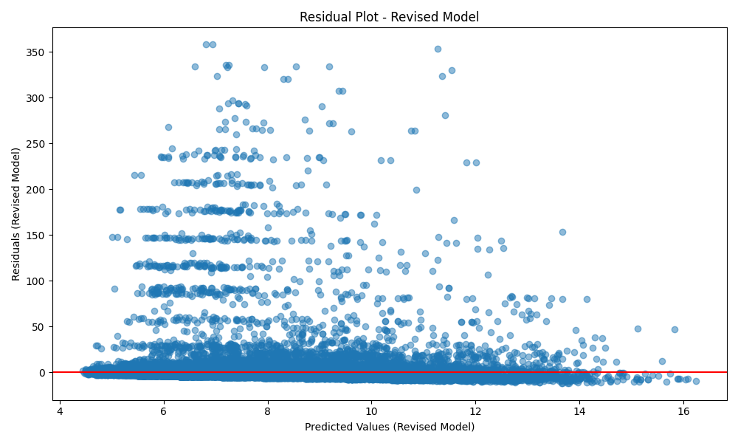
Figure: Residuals Plot (Revised Model with Climate Bins)
Variance Inflation Factor (VIF) - Revised Model:
Variable | VIF
import_from_slu_log | 5.9571
age | 9.9717
state_unemployment | 31.2639
immigrant_density_centered | 117.7269
similar | 14.9245
moderate | 17.5372
immigrant_similar | 11.3374
immigrant_moderate | 104.0449
VIF values above 10 indicate potential multicollinearity issues.

Robustness Check 1: Purpose x Immigrant Variable Interactions
Model formula: los_capped ~ import_from_slu_log + age + state_unemployment +
immigrant_density_centered + similar + moderate +
immigrant_similar + immigrant_moderate +
C(sex_enc) + C(accomd_type_enc) + C(season_enc) + C(region_census_enc) +
C(purpose_simple) + purpose_Business_x_immigrant_density + purpose_Business_x_immigrant_similar + purpose_Business_x_immigrant_moderate + purpose_Other_x_immigrant_density + purpose_Other_x_immigrant_similar + purpose_Other_x_immigrant_moderate + purpose_Pleasure_x_immigrant_density + purpose_Pleasure_x_immigrant_similar + purpose_Pleasure_x_immigrant_moderate + purpose_Wedding_x_immigrant_density + purpose_Wedding_x_immigrant_similar + purpose_Wedding_x_immigrant_moderate + purpose_Events_x_immigrant_density + purpose_Events_x_immigrant_similar + purpose_Events_x_immigrant_moderate
Generalized Linear Model Regression Results
==============================================================================
Dep. Variable: los_capped No. Observations: 139278
Model: GLM Df Residuals: 139244
Model Family: NegativeBinomial Df Model: 33
Link Function: log Scale: 1.0000
Method: IRLS Log-Likelihood: -4.1587e+05
Date: Wed, 04 Mar 2026 Deviance: 36110.
Time: 11:24:59 Pearson chi2: 2.71e+05
No. Iterations: 100 Pseudo R-squ. (CS): 0.02616
Covariance Type: nonrobust
=========================================================================================================
coef std err z P>|z| [0.025 0.975]
---------------------------------------------------------------------------------------------------------
Intercept 1.5980 0.058 27.399 0.000 1.484 1.712
C(sex_enc)[T.Male] 0.0097 0.006 1.669 0.095 -0.002 0.021
C(accomd_type_enc)[T.Other] 0.1300 0.015 8.481 0.000 0.100 0.160
C(accomd_type_enc)[T.Sharing] 0.2212 0.009 25.103 0.000 0.204 0.238
C(season_enc)[T.Spring] 0.1008 0.009 11.832 0.000 0.084 0.118
C(season_enc)[T.Summer] 0.0583 0.008 6.864 0.000 0.042 0.075
C(season_enc)[T.Winter] 0.1431 0.009 16.346 0.000 0.126 0.160
C(region_census_enc)[T.Northeast] 0.0433 0.012 3.498 0.000 0.019 0.068
C(region_census_enc)[T.South] 0.0228 0.019 1.228 0.220 -0.014 0.059
C(region_census_enc)[T.West] 0.1453 0.018 8.233 0.000 0.111 0.180
C(purpose_simple)[T.Events] 0.1589 0.039 4.036 0.000 0.082 0.236
C(purpose_simple)[T.Other] 0.4831 0.031 15.814 0.000 0.423 0.543
C(purpose_simple)[T.Pleasure] 0.1334 0.026 5.220 0.000 0.083 0.183
C(purpose_simple)[T.Wedding] 0.0311 0.030 1.030 0.303 -0.028 0.090
import_from_slu_log -0.0002 0.001 -0.315 0.753 -0.002 0.001
age 0.0051 0.000 25.531 0.000 0.005 0.005
state_unemployment -0.0263 0.005 -5.004 0.000 -0.037 -0.016
immigrant_density_centered -0.0005 0.004 -0.117 0.907 -0.009 0.008
similar -0.1409 0.050 -2.833 0.005 -0.238 -0.043
moderate -0.0646 0.044 -1.479 0.139 -0.150 0.021
immigrant_similar 0.0046 0.005 1.013 0.311 -0.004 0.014
immigrant_moderate -0.0002 0.004 -0.054 0.957 -0.009 0.008
purpose_Business_x_immigrant_density -0.0081 0.006 -1.275 0.202 -0.021 0.004
purpose_Business_x_immigrant_similar 0.0066 0.007 0.958 0.338 -0.007 0.020
purpose_Business_x_immigrant_moderate 0.0086 0.007 1.311 0.190 -0.004 0.021
purpose_Other_x_immigrant_density 0.0080 0.005 1.708 0.088 -0.001 0.017
purpose_Other_x_immigrant_similar 0.0019 0.005 0.370 0.711 -0.008 0.012
purpose_Other_x_immigrant_moderate -0.0100 0.005 -2.068 0.039 -0.019 -0.001
purpose_Pleasure_x_immigrant_density 0.0043 0.003 1.569 0.117 -0.001 0.010
purpose_Pleasure_x_immigrant_similar -0.0104 0.003 -3.572 0.000 -0.016 -0.005
purpose_Pleasure_x_immigrant_moderate -0.0041 0.003 -1.489 0.137 -0.010 0.001
purpose_Wedding_x_immigrant_density -0.0015 0.004 -0.367 0.714 -0.009 0.006
purpose_Wedding_x_immigrant_similar 0.0048 0.004 1.085 0.278 -0.004 0.014
purpose_Wedding_x_immigrant_moderate -0.0003 0.004 -0.071 0.943 -0.009 0.008
purpose_Events_x_immigrant_density -0.0032 0.010 -0.309 0.757 -0.023 0.017
purpose_Events_x_immigrant_similar 0.0017 0.011 0.156 0.876 -0.020 0.023
purpose_Events_x_immigrant_moderate 0.0056 0.010 0.531 0.595 -0.015 0.026
=========================================================================================================

Incident Rate Ratios (IRR) - Purpose Interaction Model
Variable | IRR | Lower CI | Upper CI | P-value
Intercept | 4.9431 | 4.4092 | 5.5417 | 0.0000
C(sex_enc)[T.Male] | 1.0097 | 0.9983 | 1.0212 | 0.0952
C(accomd_type_enc)[T.Other] | 1.1388 | 1.1051 | 1.1735 | 0.0000
C(accomd_type_enc)[T.Sharing] | 1.2475 | 1.2262 | 1.2693 | 0.0000
C(season_enc)[T.Spring] | 1.1061 | 1.0878 | 1.1247 | 0.0000
C(season_enc)[T.Summer] | 1.0600 | 1.0425 | 1.0778 | 0.0000
C(season_enc)[T.Winter] | 1.1538 | 1.1342 | 1.1738 | 0.0000
C(region_census_enc)[T.Northeast] | 1.0442 | 1.0192 | 1.0698 | 0.0005
C(region_census_enc)[T.South] | 1.0231 | 0.9865 | 1.0611 | 0.2195
C(region_census_enc)[T.West] | 1.1564 | 1.1171 | 1.1972 | 0.0000
C(purpose_simple)[T.Events] | 1.1723 | 1.0852 | 1.2663 | 0.0001
C(purpose_simple)[T.Other] | 1.6212 | 1.5269 | 1.7212 | 0.0000
C(purpose_simple)[T.Pleasure] | 1.1427 | 1.0869 | 1.2014 | 0.0000
C(purpose_simple)[T.Wedding] | 1.0316 | 0.9723 | 1.0945 | 0.3032
import_from_slu_log | 0.9998 | 0.9983 | 1.0012 | 0.7526
age | 1.0051 | 1.0047 | 1.0055 | 0.0000
state_unemployment | 0.9740 | 0.9640 | 0.9841 | 0.0000
immigrant_density_centered | 0.9995 | 0.9909 | 1.0082 | 0.9072
similar | 0.8686 | 0.7879 | 0.9575 | 0.0046
moderate | 0.9374 | 0.8605 | 1.0212 | 0.1390
immigrant_similar | 1.0046 | 0.9957 | 1.0136 | 0.3112
immigrant_moderate | 0.9998 | 0.9912 | 1.0084 | 0.9569
purpose_Business_x_immigrant_density | 0.9919 | 0.9796 | 1.0044 | 0.2023
purpose_Business_x_immigrant_similar | 1.0066 | 0.9931 | 1.0203 | 0.3382
purpose_Business_x_immigrant_moderate | 1.0086 | 0.9958 | 1.0217 | 0.1897
purpose_Other_x_immigrant_density | 1.0081 | 0.9988 | 1.0174 | 0.0877
purpose_Other_x_immigrant_similar | 1.0019 | 0.9919 | 1.0119 | 0.7111
purpose_Other_x_immigrant_moderate | 0.9901 | 0.9807 | 0.9995 | 0.0386
purpose_Pleasure_x_immigrant_density | 1.0043 | 0.9989 | 1.0096 | 0.1166
purpose_Pleasure_x_immigrant_similar | 0.9897 | 0.9841 | 0.9953 | 0.0004
purpose_Pleasure_x_immigrant_moderate | 0.9959 | 0.9905 | 1.0013 | 0.1366
purpose_Wedding_x_immigrant_density | 0.9985 | 0.9906 | 1.0065 | 0.7137
purpose_Wedding_x_immigrant_similar | 1.0048 | 0.9961 | 1.0136 | 0.2781
purpose_Wedding_x_immigrant_moderate | 0.9997 | 0.9915 | 1.0080 | 0.9434
purpose_Events_x_immigrant_density | 0.9968 | 0.9769 | 1.0172 | 0.7573
purpose_Events_x_immigrant_similar | 1.0017 | 0.9806 | 1.0233 | 0.8764
purpose_Events_x_immigrant_moderate | 1.0056 | 0.9851 | 1.0265 | 0.5953

Diagnostics - Robustness Check 1 (Purpose Interactions)
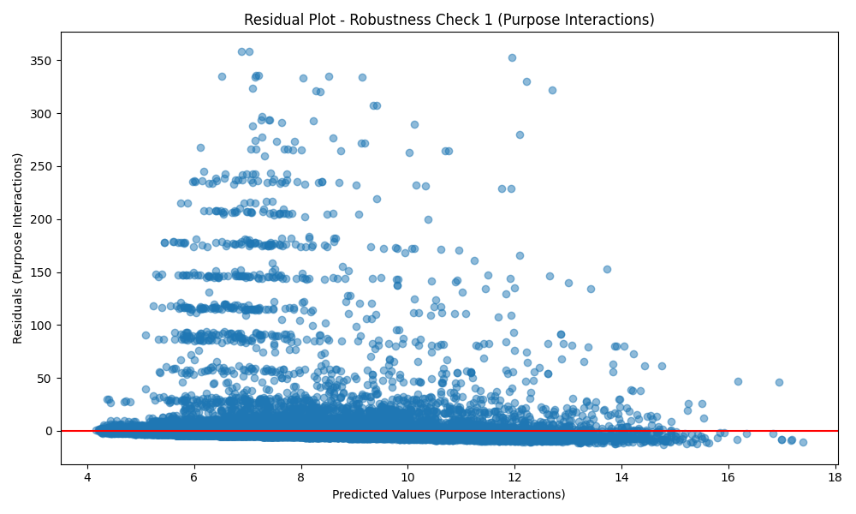
Figure: Residuals Plot (Robustness Check 1 - Purpose Interactions)
Variance Inflation Factor (VIF) - Robustness Check 1 (Purpose Interactions):
Variable | VIF
import_from_slu_log | 5.9618
age | 9.9915
state_unemployment | 31.3533
immigrant_density_centered | inf
similar | 15.0014
moderate | 17.5956
immigrant_similar | inf
immigrant_moderate | inf
purpose_Business_x_immigrant_density | inf
purpose_Business_x_immigrant_similar | inf
purpose_Business_x_immigrant_moderate | inf
purpose_Other_x_immigrant_density | inf
purpose_Other_x_immigrant_similar | inf
purpose_Other_x_immigrant_moderate | inf
purpose_Pleasure_x_immigrant_density | inf
purpose_Pleasure_x_immigrant_similar | inf
purpose_Pleasure_x_immigrant_moderate | inf
purpose_Wedding_x_immigrant_density | inf
purpose_Wedding_x_immigrant_similar | inf
purpose_Wedding_x_immigrant_moderate | inf
purpose_Events_x_immigrant_density | inf
purpose_Events_x_immigrant_similar | inf
purpose_Events_x_immigrant_moderate | inf
VIF values above 10 indicate potential multicollinearity issues.

Robustness Check 2: Accommodation x Immigrant Variable Interactions
Model formula: los_capped ~ import_from_slu_log + age + state_unemployment +
immigrant_density_centered + similar + moderate +
immigrant_similar + immigrant_moderate +
C(sex_enc) + C(purpose_simple) + C(season_enc) + C(region_census_enc) +
C(accomd_type_enc) + accomd_Hotel_x_immigrant_density + accomd_Hotel_x_immigrant_similar + accomd_Hotel_x_immigrant_moderate + accomd_Sharing_x_immigrant_density + accomd_Sharing_x_immigrant_similar + accomd_Sharing_x_immigrant_moderate + accomd_Other_x_immigrant_density + accomd_Other_x_immigrant_similar + accomd_Other_x_immigrant_moderate
Generalized Linear Model Regression Results
==============================================================================
Dep. Variable: los_capped No. Observations: 139278
Model: GLM Df Residuals: 139250
Model Family: NegativeBinomial Df Model: 27
Link Function: log Scale: 1.0000
Method: IRLS Log-Likelihood: -4.1588e+05
Date: Wed, 04 Mar 2026 Deviance: 36125.
Time: 11:26:11 Pearson chi2: 2.73e+05
No. Iterations: 100 Pseudo R-squ. (CS): 0.02606
Covariance Type: nonrobust
=======================================================================================================
coef std err z P>|z| [0.025 0.975]
-------------------------------------------------------------------------------------------------------
Intercept 1.5992 0.057 28.078 0.000 1.488 1.711
C(sex_enc)[T.Male] 0.0099 0.006 1.716 0.086 -0.001 0.021
C(purpose_simple)[T.Events] 0.1717 0.033 5.278 0.000 0.108 0.235
C(purpose_simple)[T.Other] 0.4251 0.026 16.348 0.000 0.374 0.476
C(purpose_simple)[T.Pleasure] 0.1309 0.022 5.948 0.000 0.088 0.174
C(purpose_simple)[T.Wedding] 0.0086 0.026 0.336 0.737 -0.042 0.059
C(season_enc)[T.Spring] 0.1028 0.009 12.066 0.000 0.086 0.120
C(season_enc)[T.Summer] 0.0591 0.008 6.959 0.000 0.042 0.076
C(season_enc)[T.Winter] 0.1446 0.009 16.521 0.000 0.127 0.162
C(region_census_enc)[T.Northeast] 0.0384 0.012 3.105 0.002 0.014 0.063
C(region_census_enc)[T.South] 0.0222 0.019 1.193 0.233 -0.014 0.059
C(region_census_enc)[T.West] 0.1441 0.018 8.166 0.000 0.110 0.179
C(accomd_type_enc)[T.Other] 0.1451 0.019 7.772 0.000 0.108 0.182
C(accomd_type_enc)[T.Sharing] 0.2329 0.011 21.606 0.000 0.212 0.254
import_from_slu_log -0.0003 0.001 -0.353 0.724 -0.002 0.001
age 0.0051 0.000 25.549 0.000 0.005 0.005
state_unemployment -0.0266 0.005 -5.069 0.000 -0.037 -0.016
immigrant_density_centered 0.0043 0.003 1.283 0.199 -0.002 0.011
similar -0.1364 0.050 -2.747 0.006 -0.234 -0.039
moderate -0.0621 0.044 -1.423 0.155 -0.148 0.023
immigrant_similar -0.0031 0.003 -0.906 0.365 -0.010 0.004
immigrant_moderate -0.0048 0.003 -1.440 0.150 -0.011 0.002
accomd_Hotel_x_immigrant_density -0.0026 0.002 -1.500 0.134 -0.006 0.001
accomd_Hotel_x_immigrant_similar -8.925e-05 0.002 -0.048 0.962 -0.004 0.004
accomd_Hotel_x_immigrant_moderate 0.0019 0.002 1.063 0.288 -0.002 0.005
accomd_Sharing_x_immigrant_density 0.0062 0.002 2.787 0.005 0.002 0.011
accomd_Sharing_x_immigrant_similar -0.0036 0.002 -1.478 0.139 -0.008 0.001
accomd_Sharing_x_immigrant_moderate -0.0049 0.002 -2.127 0.033 -0.009 -0.000
accomd_Other_x_immigrant_density 0.0007 0.003 0.211 0.833 -0.006 0.007
accomd_Other_x_immigrant_similar 0.0006 0.004 0.161 0.872 -0.007 0.008
accomd_Other_x_immigrant_moderate -0.0018 0.003 -0.509 0.611 -0.009 0.005
=======================================================================================================

Incident Rate Ratios (IRR) - Accommodation Interaction Model
Variable | IRR | Lower CI | Upper CI | P-value
Intercept | 4.9493 | 4.4265 | 5.5338 | 0.0000
C(sex_enc)[T.Male] | 1.0100 | 0.9986 | 1.0215 | 0.0862
C(purpose_simple)[T.Events] | 1.1873 | 1.1140 | 1.2655 | 0.0000
C(purpose_simple)[T.Other] | 1.5297 | 1.4537 | 1.6097 | 0.0000
C(purpose_simple)[T.Pleasure] | 1.1399 | 1.0917 | 1.1901 | 0.0000
C(purpose_simple)[T.Wedding] | 1.0086 | 0.9593 | 1.0605 | 0.7367
C(season_enc)[T.Spring] | 1.1083 | 1.0899 | 1.1269 | 0.0000
C(season_enc)[T.Summer] | 1.0609 | 1.0434 | 1.0787 | 0.0000
C(season_enc)[T.Winter] | 1.1556 | 1.1359 | 1.1755 | 0.0000
C(region_census_enc)[T.Northeast] | 1.0391 | 1.0143 | 1.0646 | 0.0019
C(region_census_enc)[T.South] | 1.0224 | 0.9859 | 1.0603 | 0.2328
C(region_census_enc)[T.West] | 1.1550 | 1.1158 | 1.1957 | 0.0000
C(accomd_type_enc)[T.Other] | 1.1561 | 1.1146 | 1.1992 | 0.0000
C(accomd_type_enc)[T.Sharing] | 1.2622 | 1.2359 | 1.2892 | 0.0000
import_from_slu_log | 0.9997 | 0.9983 | 1.0012 | 0.7244
age | 1.0051 | 1.0047 | 1.0055 | 0.0000
state_unemployment | 0.9737 | 0.9637 | 0.9838 | 0.0000
immigrant_density_centered | 1.0043 | 0.9977 | 1.0109 | 0.1994
similar | 0.8725 | 0.7916 | 0.9617 | 0.0060
moderate | 0.9398 | 0.8628 | 1.0237 | 0.1547
immigrant_similar | 0.9969 | 0.9902 | 1.0036 | 0.3648
immigrant_moderate | 0.9952 | 0.9888 | 1.0017 | 0.1498
accomd_Hotel_x_immigrant_density | 0.9974 | 0.9941 | 1.0008 | 0.1336
accomd_Hotel_x_immigrant_similar | 0.9999 | 0.9963 | 1.0035 | 0.9615
accomd_Hotel_x_immigrant_moderate | 1.0019 | 0.9984 | 1.0053 | 0.2876
accomd_Sharing_x_immigrant_density | 1.0062 | 1.0018 | 1.0106 | 0.0053
accomd_Sharing_x_immigrant_similar | 0.9964 | 0.9916 | 1.0012 | 0.1394
accomd_Sharing_x_immigrant_moderate | 0.9952 | 0.9907 | 0.9996 | 0.0334
accomd_Other_x_immigrant_density | 1.0007 | 0.9941 | 1.0073 | 0.8330
accomd_Other_x_immigrant_similar | 1.0006 | 0.9934 | 1.0079 | 0.8719
accomd_Other_x_immigrant_moderate | 0.9982 | 0.9914 | 1.0051 | 0.6110

Diagnostics - Robustness Check 2 (Accommodation Interactions)
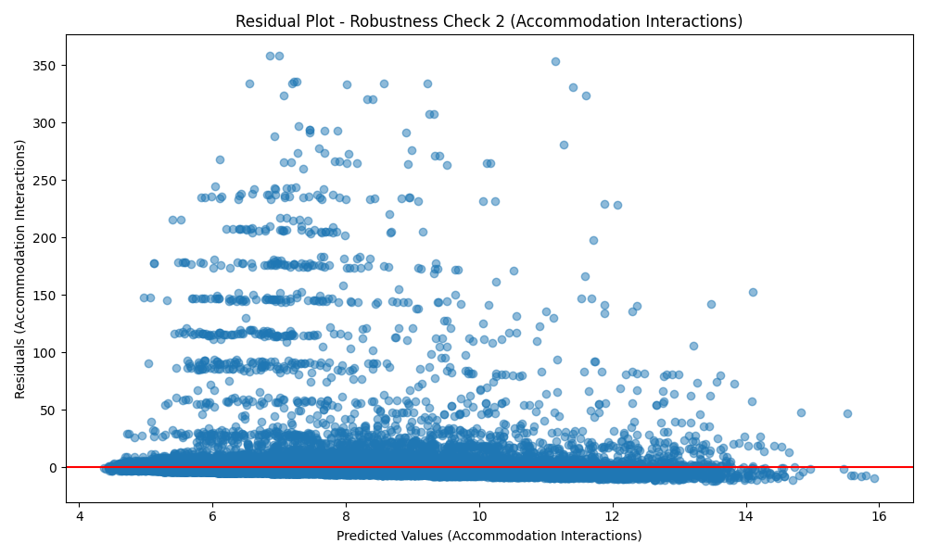
Figure: Residuals Plot (Robustness Check 2 - Accommodation Interactions)
Variance Inflation Factor (VIF) - Robustness Check 2 (Accommodation Interactions):
Variable | VIF
import_from_slu_log | 5.9614
age | 9.9826
state_unemployment | 31.2892
immigrant_density_centered | inf
similar | 14.9571
moderate | 17.5606
immigrant_similar | inf
immigrant_moderate | inf
accomd_Hotel_x_immigrant_density | inf
accomd_Hotel_x_immigrant_similar | inf
accomd_Hotel_x_immigrant_moderate | inf
accomd_Sharing_x_immigrant_density | inf
accomd_Sharing_x_immigrant_similar | inf
accomd_Sharing_x_immigrant_moderate | inf
accomd_Other_x_immigrant_density | inf
accomd_Other_x_immigrant_similar | inf
accomd_Other_x_immigrant_moderate | inf
VIF values above 10 indicate potential multicollinearity issues.

